### 

### 

# **(IMD274_FP_Kcummins [Space Adventure])**

Created By: (Kelsey M Cummins) - version: 0.0

## **Game Pillars:**

1. Explore the ship
2. Eliminate any intruders

### 

### 

## **Game Introduction**

A general overview of the game, with the idea anyone can read and understand what the game is like. Everyone that reads this should be able to understand what the basic idea of this game is. This part of the document is one that will change very little once the concept is accepted.

#### Genre: Sci-Fi

#### Gameplay: First person

#### Target audience & platforms: people of any age or gender who enjoy a good sci-fi game, platforms include Xbox One, PS4, and PC, expected ESRB: T or M

#### Look and Feel

This is a good place to describe the experience you want the player to have. What they see, and feel will ultimately define your experience for them.

### Story

You are the lone survivor on the Galactic Firebird, your mission: protect the ship from any and all intruders at all costs.

### How to Play

The rules are simple, explore the ship and blast any intruders seen. The player cannot leave the ship itself and is confined to the interior of the ship. The player will be notified if they go out of bounds. Players may earn points by finding hidden loot (i.e. new weapons such as upgraded blasters.)

## **Technical**

Defines the technical aspects of the game. Includes the physical game requirements needed to play and specifies which platforms the game will be developed, which engines will be used, etc.

The technical section is best achieved with consensus from the people responsible for the Visual, Programming and Audio aspects.

### System Requirements

For PC, Windows 8 or higher, with at least 4 GB of RAM (preferably 8 GB), a decent graphics card such as an NVIDIA GEFORCE (which is the graphics card on my PC), and an intel core i5 or i7 processor. Ideally the game would be best suited for a gaming PC but an upgraded standard PC could easily work. For console it would be Xbox One and PS4 with Xbox Live or PlayStation Network enabled for update and installation purposes, with a source of external memory installed for basic installation of the game and any expansion packs that could be released.

### User Interface (controls)

A description of the user’s control of the game. It is also recommended to think about which buttons on a device would be best suited for the game. Consider what the worst layout is, then ask yourself if your UI is still playable? A visual representation can be added.

## 

## **Artwork (design)**

A list of technical requirements from those in concerned with the visual aspects of the game. This is a section that will require extensive meetings with a graphic designer.

### Characters

Provide a list of all characters that will be in the game and provide variations of different visual states for each.

#### Alex Kava

Last surviving member of the Galactic Firebird, his duty is to protect the ship from any intruders at any cost. As the game is first-person, we never get a good look at Alex’s appearance, he is covered by a spacesuit and most of the game we only see his hands. From what we can see, his weapon of choice is a blaster. Alex can be described as brave and incredibly loyal, he’s the kind of guy to put the safety of his crewmates first. Now he is full of guilt for not being able to save them…

### Level Design

Create the variations of the game's levels—locales, stages, or missions. Level design for each individual level starts with concept art, sketches, renderings, and/or physical models.

Level design can best be shown as a flow chart.

Use generic names to create level design.

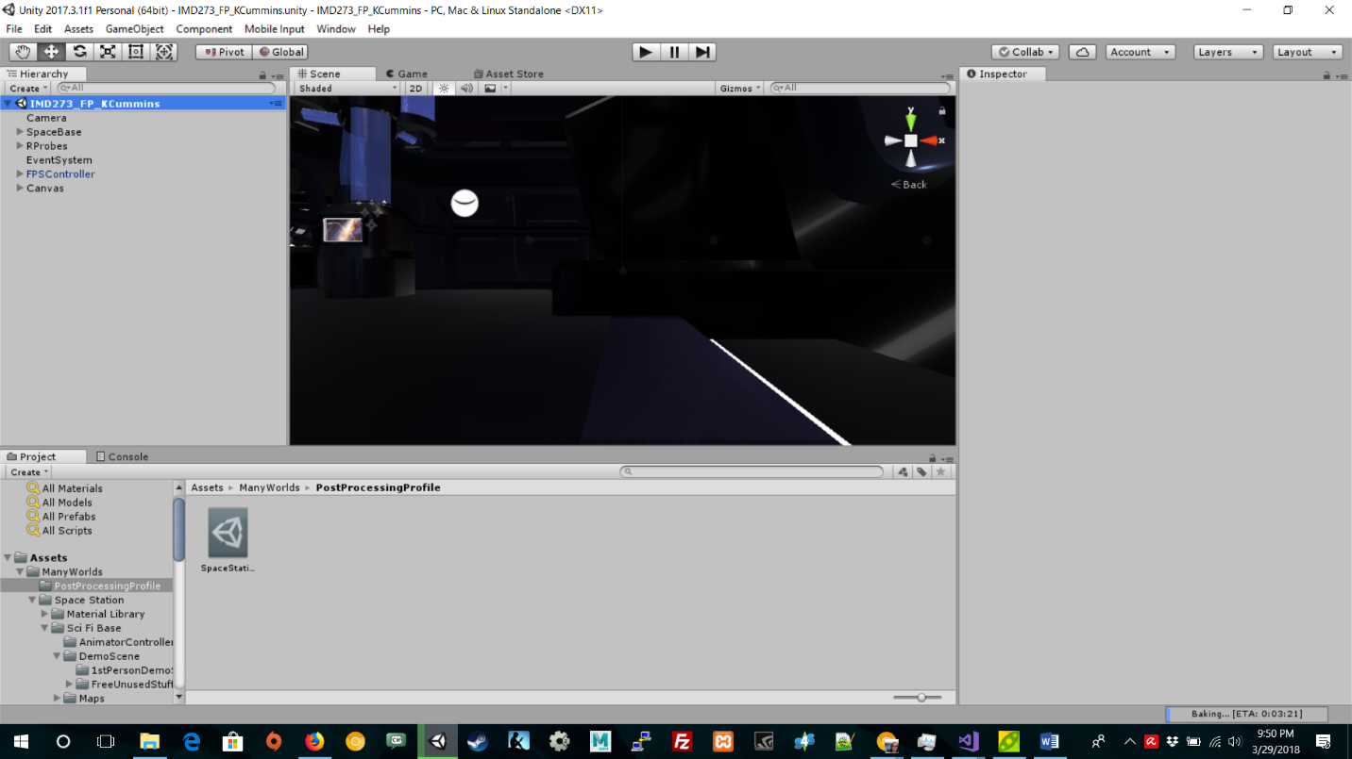

This is a preview of what the levels in my game will look like.

## **Programming**

Define the overall structure of the programming for the game. You can divide this into as much detail as you may need to manage, but this is for development.

### Player System

World System

## 

## 

## **Audio & Sound F/x**

The music will set the entire tone for the game. It is very important to communicate with the audio designer before and while the audio content is being

developed.

### Player Elements

Define the types of sounds and effects that the player will experience from sounds to vibrations.

### Global Elements

Defines the overall gameplay sounds such as background music and ambient sounds.

### 

Much of this document was borrowed from dundoc.com. It’s an excellent resource for writing game design documents. Feel free to use it instead if you like, but make note of the differences.